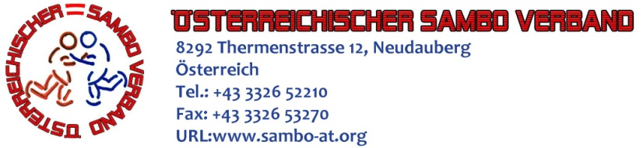

PROGRAMM
III OPEN AUSTRIAN SAMBO CHAMPIONSHIP 2013
(AUSTRIAN TROPHY 2013)

Place: Аustria, Linz, sport club «Boxing-MMA Linz»
Address: 4020 Linz, Industriezeile 47
Date: 11 - 13 October 2013

Date | Time / Place | Event
11 October 2013 | 15.00 – 17.00  «Boxing-MMA Linz» | Arrival and accreditation
 | 17.00 – 18.00  «Boxing-MMA Linz» | Comission and team meting
 | 18.00 – 19.00  «Boxing-MMA Linz» | Weighing procedure.  COMBAT SAMBO  MAN (1992 year of birth also are more senior).  Weight categories: 52,57,62,68,74,82,90,100,+100  SPORT SAMBO  Men (1992 year of birth also are more senior).  Weight categories: 52,57,62,68,74,82,90,100,+100  Women (1992 year of birth also are more senior).  Weight categories: 44,48,52,56,60,64,68,72,80,+80  Juniors (m): (1993-94 y.b).  Weight categories: 52,57,62,68,74,82,90,100,+100  Juniors (f) (1993-94 y.b.).  Weight categories: 44,48,52,56,60,64,68,72,80,+80  Juniors (m): (1995-1996 y.b.).  Weight categories: 48,52,56,60,65,70,75,81,87,+87  Juniors (f): (1995-1996 y.b.).  Weight categories: 40,44,48,52,56,60,65,70,75,+75  Cadets (m) (1997-1998 y.b.).  Weight categories: 42,46,50,55,60,66,72,78,84,+84  Cadets (f) (1997-1998 y.b.).  Weight categories: 38,41,44,48,52,56,60,65,70,+70  Boys (1999-2000 y.b.).  Weight categories: 30,32,35,38,41,45,49,53,57,62,67,+67  Girls (1999-2000 y.b.).  Weight categories: 26,28,30,32,34,36,38,41,45,49,53,+53  Boys (2001-2002 y.b.).  Weight categories: 30,32,35,38,41,45,49,53,57,62,67,+67  Girls (2001-2002 y.b.).  Weight categories: 26,28,30,32,34,36,38,41,45,49,53,+53  Boys (2003-2004 y.b.).  Weight categories: 26,28,30,32,35,38,41,45,49,+49  Girls (2003-2004 y.b.).  Weight categories: 22,24,26,28,30,32,34,36,38,+38
12 October 2013 | 8.00-8.30  «Boxing-MMA Linz» | Weighing procedure
12 October 2013 | 8.30-9.00  «Boxing-MMA Linz» | Draw
12 October 2013 | 10.00  «Boxing-MMA Linz» | Preliminaries & Repechage
12 October 2013 | 17.00 | Finals
12 October 2013 | 19.00 | Gala evening
13 October 2013 | All day | Departure of the delegations

At the weigh competitors impose PASSPORT or identification document.
Entry fee for each participant - 15 euros.
Equipment of the competitors in SPORT SAMBO (wrestling shoes, red, blue shorts, red and blue jacket).
Equipment of the competitors in COMBAT SAMBO (wrestling shoes, red, blue shorts, red and blue jackets, boxing helmet, protection for feet and cap, shock-gripping gloves).
To participate in competitions athletes have passed a medical examination by a doctor.
All competitors must have medical insurance covering the costs associated with the possible occurrence of injuries in competition.
Information on the rules of the competition, the applications for the competition, athletes equipment you can get by e-mail: austria-sambo@mail.ru or by phone (+43-660-426-9824) - Viktor Pavlov.

