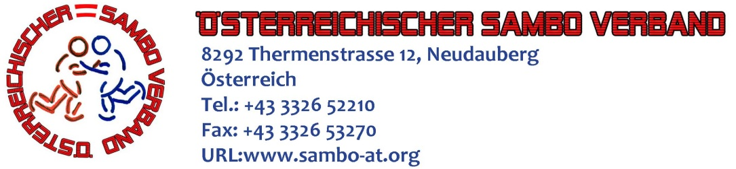

То Presidents of Nationals SAMBO Federations

Dear Mr. President,

Austrian SAMBO Federation (ASF) is pleased to invite your federation to participate in the III Open Austrian SAMBO Championship in sport and combat SAMBO devoted 75th Anniversary of the Sambo . Competitions will be held from 11 to 13 October 2013 in Linz (Austria) to: 4020 Linz, Industriezeile 47, sport club «Boxing-MMA Linz».
We ask you to submit a preliminary application for participation in the period up to October 1, 2013 to the email address: austria-sambo@mail.ru in the name of Viktor Pavlov (Tel. +43-660-426-9824).
We ask you to submit preliminary application for hotel accommodation of the city of Linz or sports club «Boxing-MMA Linz» (budget option), as well as transfers from the airport of Vienna (Vienna airport-Linz-Vienna airport) in the period up to October 1, 2013 by e-mail: sened@gmx.at addressed Nedzad Secibovic (Tel. +43-660-711-0017).
This invitation is the official document for the competition.

Kind regards,
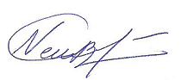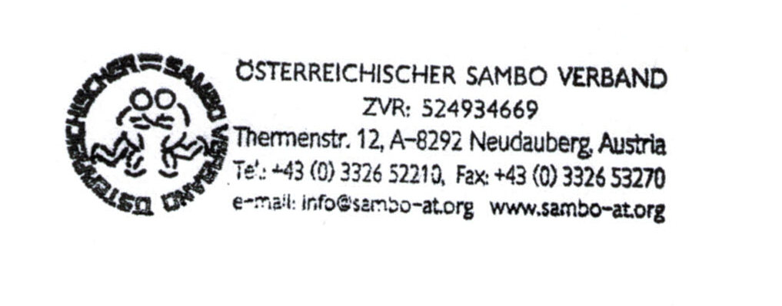
Svetlana Neubauer-Sokolik
President ASF

Please find attached the program of the competition.

