ESF CONGRESS PROCEDURES
This document contains the description and explanation of the procedure for holding the ESF Congress, which will be held for the first time in a hybrid format on November 6, 2020 in Novi Sad (Serbia).

REMOTE ATTENDANCE
Representatives of the National SAMBO Federations participating in the Congress online by means of Zoom conference must accomplish the following steps:

1) Register in advance an NSF account in the Zoom - https://zoom.us or use an existing account.
The visible account name must contain the name of the representative and the country, for example, Ivan Ivanov Russia.

2) Use the technical capabilities of Zoom for electronic voting after the start of voting on the agenda items
(finger UP icon - FOR, finger DOWN icon - AGAINST, arrow icon - ABSTAINED).
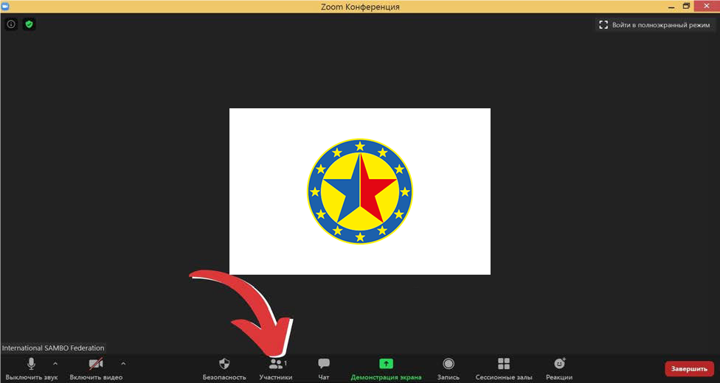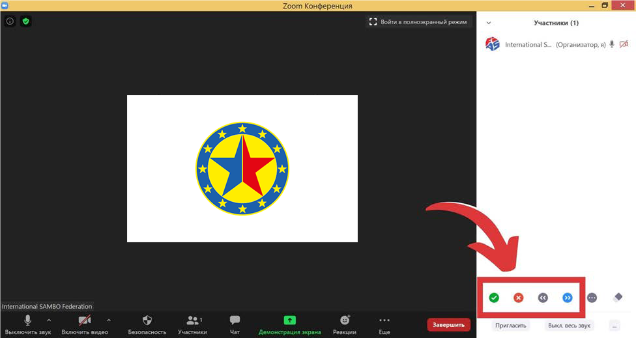

Only NSF representatives indicated in the mandate form, sent to the official ESF e-mail address eurosambo@gmail.com before October 30, 2020, are allowed to participate in the ESF Congress via Zoom.

Members of the ESF Registration Commission make themselves the entry of the NSF representative into the Congress registration sheet, indicating that the NSF representative participates in voting via Zoom.

The votes shall be counted by the Scrutineers, summarizing the personal voting in the Congress hall and the electronic voting via Zoom.

If the NSF representative participating via Zoom wishes to speak at the ESF Congress, the NSF representative should use the palm icon or writes a request / question in the Zoom conference chat. The working languages of the Congress are English and Russian.

In case of technical failures, the NSF representative participating in the Congress via Zoom should re-enter the Congress conference.

