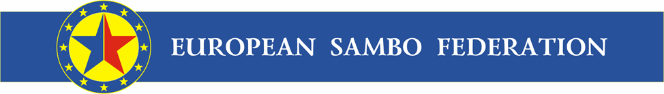
President of national sambo federation,
Member of ESF
23 October 2014

Quota of National Sambo Federations’ athletes of Europe
for the 1st European Games «Baku-2015»
TOTAL: 77 athletes
Women
52 (9) | 60 (9) | 64 (9) | 68 (9)
ARM | AZE | AZE | AZE
AZE | BLR | BLR | BLR
BLR | BUL | BUL | BUL
BUL | ESP | FRA | FRA
FRA | GEO | ISR | GEO
IRL | ISR | MDA | MDA
LTU | MDA | ROU | RUS
ROU | ROU | RUS | SRB
RUS | RUS | UKR | UKR
Men
57 (8) | 74 (16) | 90 (8) | +100 (9)
ARM | AZE | ARM | AUT
AZE | BLR | AZE | AZE
BLR | BUL | BLR | BLR
BUL | ESP | GEO | GEO
GEO | FRA | LTU | MKD
ROU | GEO | MDA | ROU
RUS | IRL | RUS | RUS
UKR | ITA | UKR | SRB
 | LAT |  | UKR
 | POL
 | ROU
 | RUS
 | SLO
 | SRB
 | TUR
 | UKR
Sincerely Yours,  Sergey Eliseev  European Sambo Federation President | 