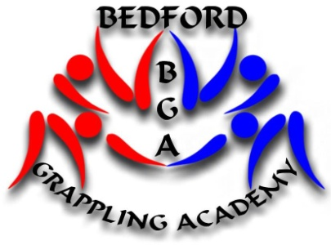
Bedford Grappling Academy
Presents
23rd British Open 2013
Sombo Championships & Trials
Full Contact Combat Sambo Championships & Trials

This will be point-scoring event for both
Those who wish to be considered for the World Championships and World Combat Games must attend this event
Sombo /Full Contact Combat Sambo
Venue: Biddenham International School, Biddenham Turn, Bedford, MK40 4AZ
DATE SUNDAY 30TH JUNE 2013 weigh-in 10 am for all categories
This competition is open to all Clubs/Associations affiliated to the British Sombo Federation and FIAS Countries. Individuals must be members of one of the above proof will be required.
We will be holding Full Contact Sombo (known in Russia as Combat Sambo) event under FIAS rules. Insurance for Full Contact is required and proof of this must be sent in with entry forms.
Weight and Age Categories
Sombo:
Men:18 years and above 62 kg, 68 kg, 74 kg, 82 kg, 90 kg, 100 kg, +100 kg,
Master Men and Women 35 years to 44 years, 45 years to 54 years, 55 years and over. These will be matched as entries come in.
Youth: 15 -17 years 48 kg, 52 kg, 56 kg, 60 kg, 65 kg, 70 kg, 75 kg, 81 kg, 87 kg, +87 kg
School boys & girls: 12, 13, 14years 29 kg 32 kg 35 kg 38 kg 42 kg 47 kg 53 kg 59 kg 66 kg 73 kg +73 kg
Junior boys & girls: 9, 10, 11years 29 kg 32 kg 35 kg 38 kg 42 kg 47 kg 53 kg 59 kg
66 kg + 66 kg
Junior and School boys & girls, will be allowed judo jacket with red and blue belt and shorts, this is to encourage young judo players to have a go
Ladies-Young Women-School Girls will be matched.
Competitors can enter one age above themselves
FULL CONTACT SOMBO (Combat Sambo) : Proof of age
Men:18 years and above 62 kg, 68 kg, 74 kg, 82 kg, 90 kg, 100 kg, +100 kg
Weigh In for Senior & Masters Sombo and Full Contact Sombo 12:00. All other Categories 10:00.
FEE £15 per entry
PLEASE READ CAREFULLY
All Competitors must send proof of membership to a Recognised Club or Association. If you are a member of the IBF/BCSA or GrapplingUK there is no need we have your records on file.
Full Contact Sombo (Combat Sambo) must obtain insurance for a Full Contact event.
I can offer full contact insurance £15 per year, THIS MUST BE DONE WELL IN ADVANCE
Membership Certificates, Full Contact Sombo Insurance must be sent with entry form so they can be checked. I have a doctor who will check the full contact fighters are fit to compete

CLOSING DATE
23RD JUNE 2013
Bedford.grappling.academy@gmail.com
Russell Dodds Home 01234 346112 Mobile 07889146662
Bedford is well placed for any international teams to travel to, you can fly into Luton Aeroport which has a five minute shuttle bus ride to the train station then 15 minute train ride to the venue and hotels, or if any teams are interested I can arrange pick up from the airport and hotels at a good rates please email for more details

