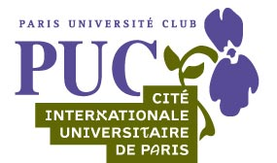

13th SAMBO GREAT PRIZE OF PARIS

HISTORY – MAPS - ACCOMODATIONS

We are happy to invite you to the 13th edition of the Sambo Great Prize of Paris.
It is organized every year since 2000 in Paris, at the Charléty Stadium (13th district of Paris)

1. Airports serving Paris:

The airport Roissy CHARLES OF GAULLE is the principal Parisian terminal. It is located North-East of Paris. The airport of ORLY is the second airport serving the capital. It is located South of Paris. For all information on the operation of the airport platform of Paris, please go to the website::
http://www.aeroportsdeparis.fr and check the English version

2. Transfers

The Charléty Stadium is accessible by the RER B, Paris rail suburban network starting from two airports (directly starting from Roissy CDG, via Orlyval with change at Antony station from Orly airport). To use public transport from these two airports:
http://www.aeroportsdeparis.fr/Adp/fr-FR/Passagers/Arrivees/QuitterAeroport/EnTransportEnCommun/EnTransportsEnCommun.htm

3. The Charléty Stadium :
Construction date | 1939
Modification date | 1994
Capacity | 20,000 seats
Seats colour | grey
Adress | 1 Av. Pierre de Coubertin  75013 Paris, FRANCE

The Charléty Stadium is a sports complex of Paris. The new Charléty Stadium is an omnisport complex, including a stadium of athletics and Rugby of high capacity (20, 000 seats), a football field, an omnisport room (Charpy room) of 1,500 seats where the GPPS is organized every year, specialized rooms (body-building, gymnastics, dojo), eight tennis courts, squash courts. It also hosts the House of the French sport, with the offices of the French Olympic Sporting Committee and the French Federation of Athletics.

HISTORY

The PUC is driven out in 1929 of its Porte Dorée Stadium. It is only in 1937 that it is allotted a waste ground next to the Porte de Gentilly. The Sebastien Charléty Stadium, of the name of a vice-chancellor who worked much for obtaining this stadium for the PUC, is inaugurated in 1939. During the war, work continues. This place is also the first one of Paris to be liberated by a detachment of the 2nd Armoured Division commanded by Field Marshall Leclerc. Works continued: wooden steps appeared then cloakrooms and finally a Club-house. Charléty welcomes its first great sporting event in September 1957 with the university Games of Paris. The runner Michel Jazy beat the world record there on 2,000 meters in 1962. In 1968, a nonsporting event takes place there. On May 27, the meeting of the national Union of the students of France, the most outstanding meeting of the events of May 68, proceeds there. From 30,000 to 50,000 people are gathered there. The stadium continues to welcome amateur and professional sporting events, as well as different sport sections from the PUC. Then in 1980, after a record of France by Marajo on 1,000 m, the pucist Philippe Houvion beat the world record of pole jump with 5.77meters

.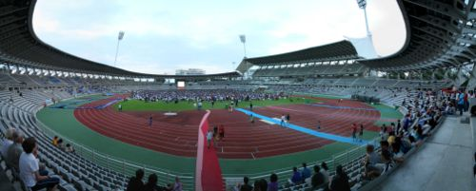
The new Charléty Stadium at the time of the Football World Cup in 2006 ⬆
Becoming dangerous, it is demolished at the end of the year 1989. A new stadium is built since 1991 for 120 million Euros, then inaugurated in 1994 (architects: Henri and Bruno Gaudin).
The new Charléty Stadium hosts within its Charpy room the Paris Volley club, originating from the volley ball section of the PUC, and several times champions of France. It welcomes in 1999, the European Nations Cup of athletics. The athletics meeting of Paris of the Golden league takes place there also several times, as in 2002 when American Tim Montgomery there beat the world record of the 100 m (9 seconds 78) but which is now controversial due to the polemic of the "record of the world" program initiated by Victor Conte, founder of the Balco laboratory. In 2002 and 2003 this stadium has hosted CAMP MASTER' S, a competition of international Paintball. French Paintball entered a major stadium for the first time. This stadium was used during the World cup of football 2006 in Germany: French fans had the occasion to see on a giant screen the 7 matches of the French team, which gathered several times more than 10,000 people. Others matches were broadcast there, like Brazil vs Australia or Portugal vs England.
The Paris University Club (PUC) is the largest university sports Club in France with 10,000 members and more than 60 sports from amateur practice to competition level.

MAPS

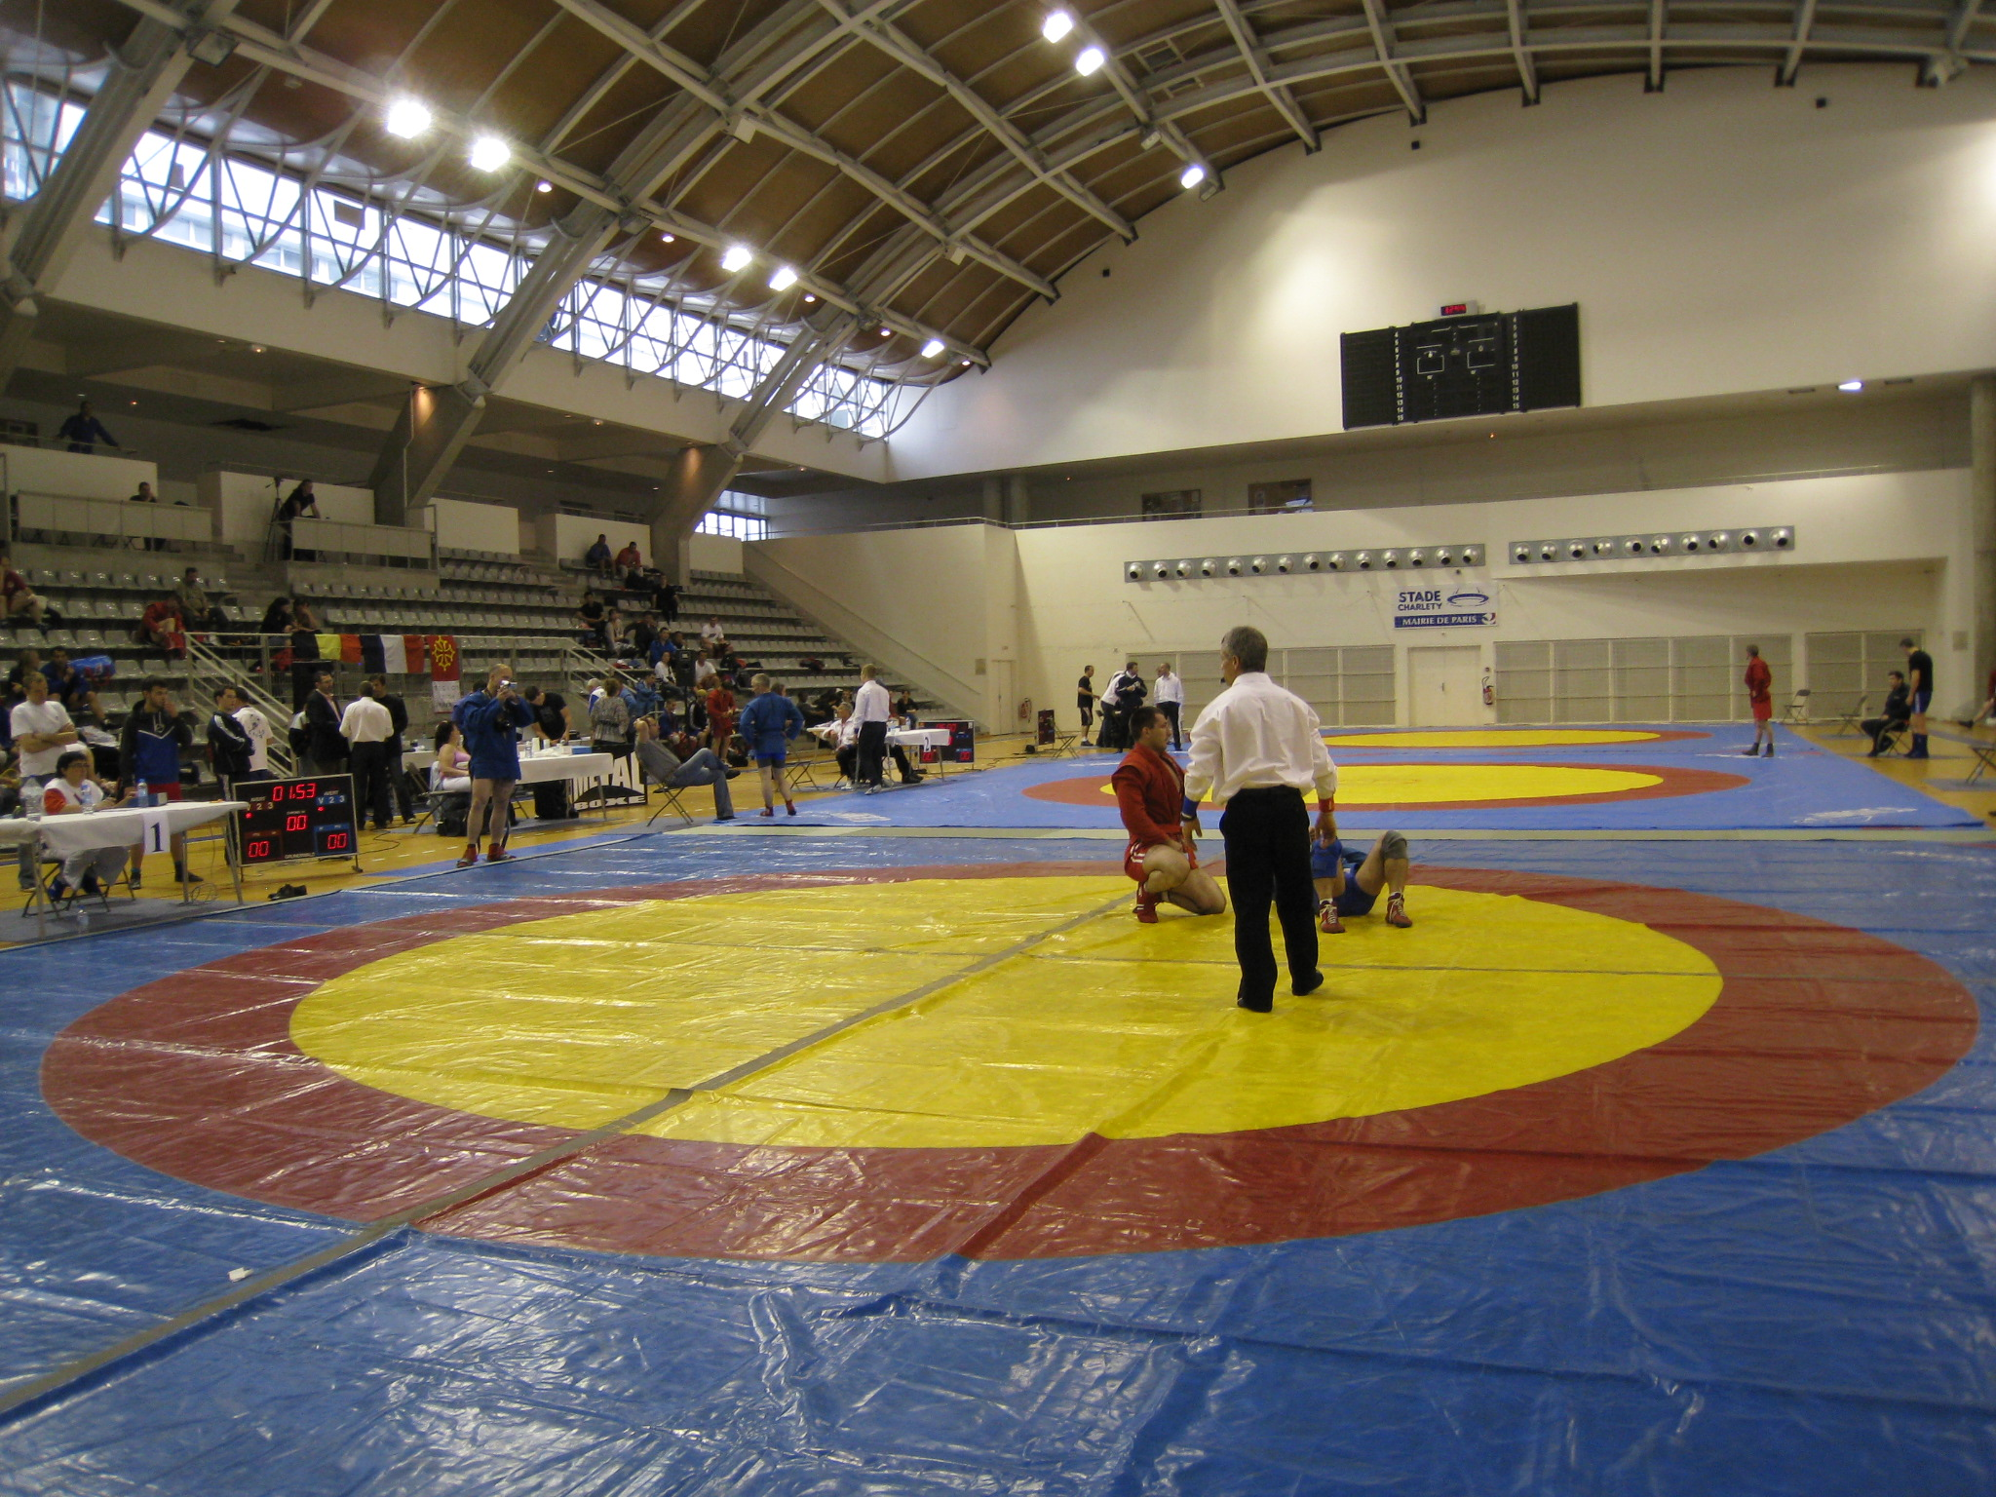

CHARLETY STADIUM- Charpy Room

17, avenue Pierre de Coubertin 75013 PARIS

To get to the Charléty Stadium, 17 avenue Pierre de Coubertin in 13th district, you can take the RER line B University Cité station or the buses number 21, 67, 88 and PC.

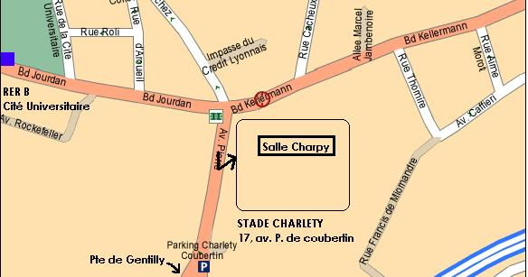
Entry

The Pierre Charpy room is an ultra modern gymnasium of 1,500 seats hosting all major indoor sports, Volley ball, Basket, Handball, Judo tournaments, Karate, dance championships, boxing matches and to perfectly end the sport season, SAMBO.

INFO-Line: +336 63 98 65 74
Théodore ASLAMATZIDIS, Protocol Chief of the Event

ACCOMODATION

Remember that transfers, displacements, lodging as well as the meals are the responsibility of the participants.

HOTELS NEAR THE CHARLETY STADIUM (PARIS 13th district)

Less than 500 meters:

Centre International de Séjour de Paris KELLERMANN (The best choice) – 300 rooms
17 Boulevard Kellerman
75013 PARIS
Tél. : +331 44 16 37 38
Fax : +331 44 16 37 39
E-mail : reservation@cisp.asso.fr
Site website and online registration: http://www.cisp.asso.fr/
Prices :
Single room (Shower and Toilets) | 35,00 EUR
Room with 2 beds (Shower and Toilets) | 24,50 EUR
Chamber of 2 to 4 beds | 22,50 EUR
Chamber with 8 Beds | 18,50 EUR
(Price per person)

HOTEL Ibis** Paris Porte d’Italie
13, rue du Val de Marne
94250 GENTILLY
1 single room: 49.00 EUR
Breakfast: 6.00 EUR
Tél. : +331 49 69 94 94
Fax : +331 45 46 41 52

HOTEL CAMPANILE** PARIS (Porte d'Italie) - Le Kremlin-Bicêtre
2 BLD DU GENERAL DE GAULLE
94270 KREMLIN-BICETRE
Tél. +331 46 70 11 86
Fax : +33146706447
E-mail :lekremlinbicetre@campanile.fr
1 single room: 69.00 EUR

A L’IDEAL HOTEL** (Porte d’Orleans)
108, Boulevard Jourdan
75014 PARIS
Tél. : +331 45 40 45 16
Fax : +331 45 39 05 82
Single room: 75 EUR
2 beds room 95 EUR

