 | 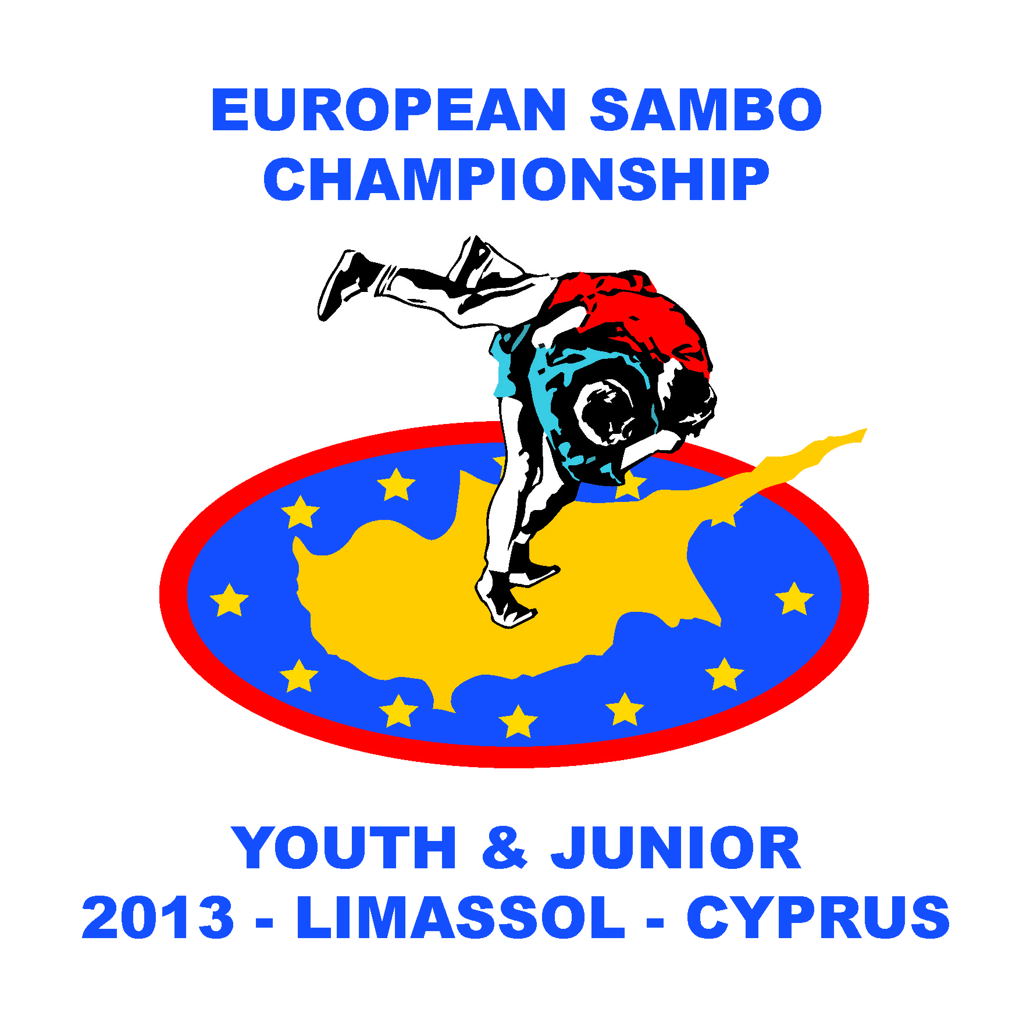 | 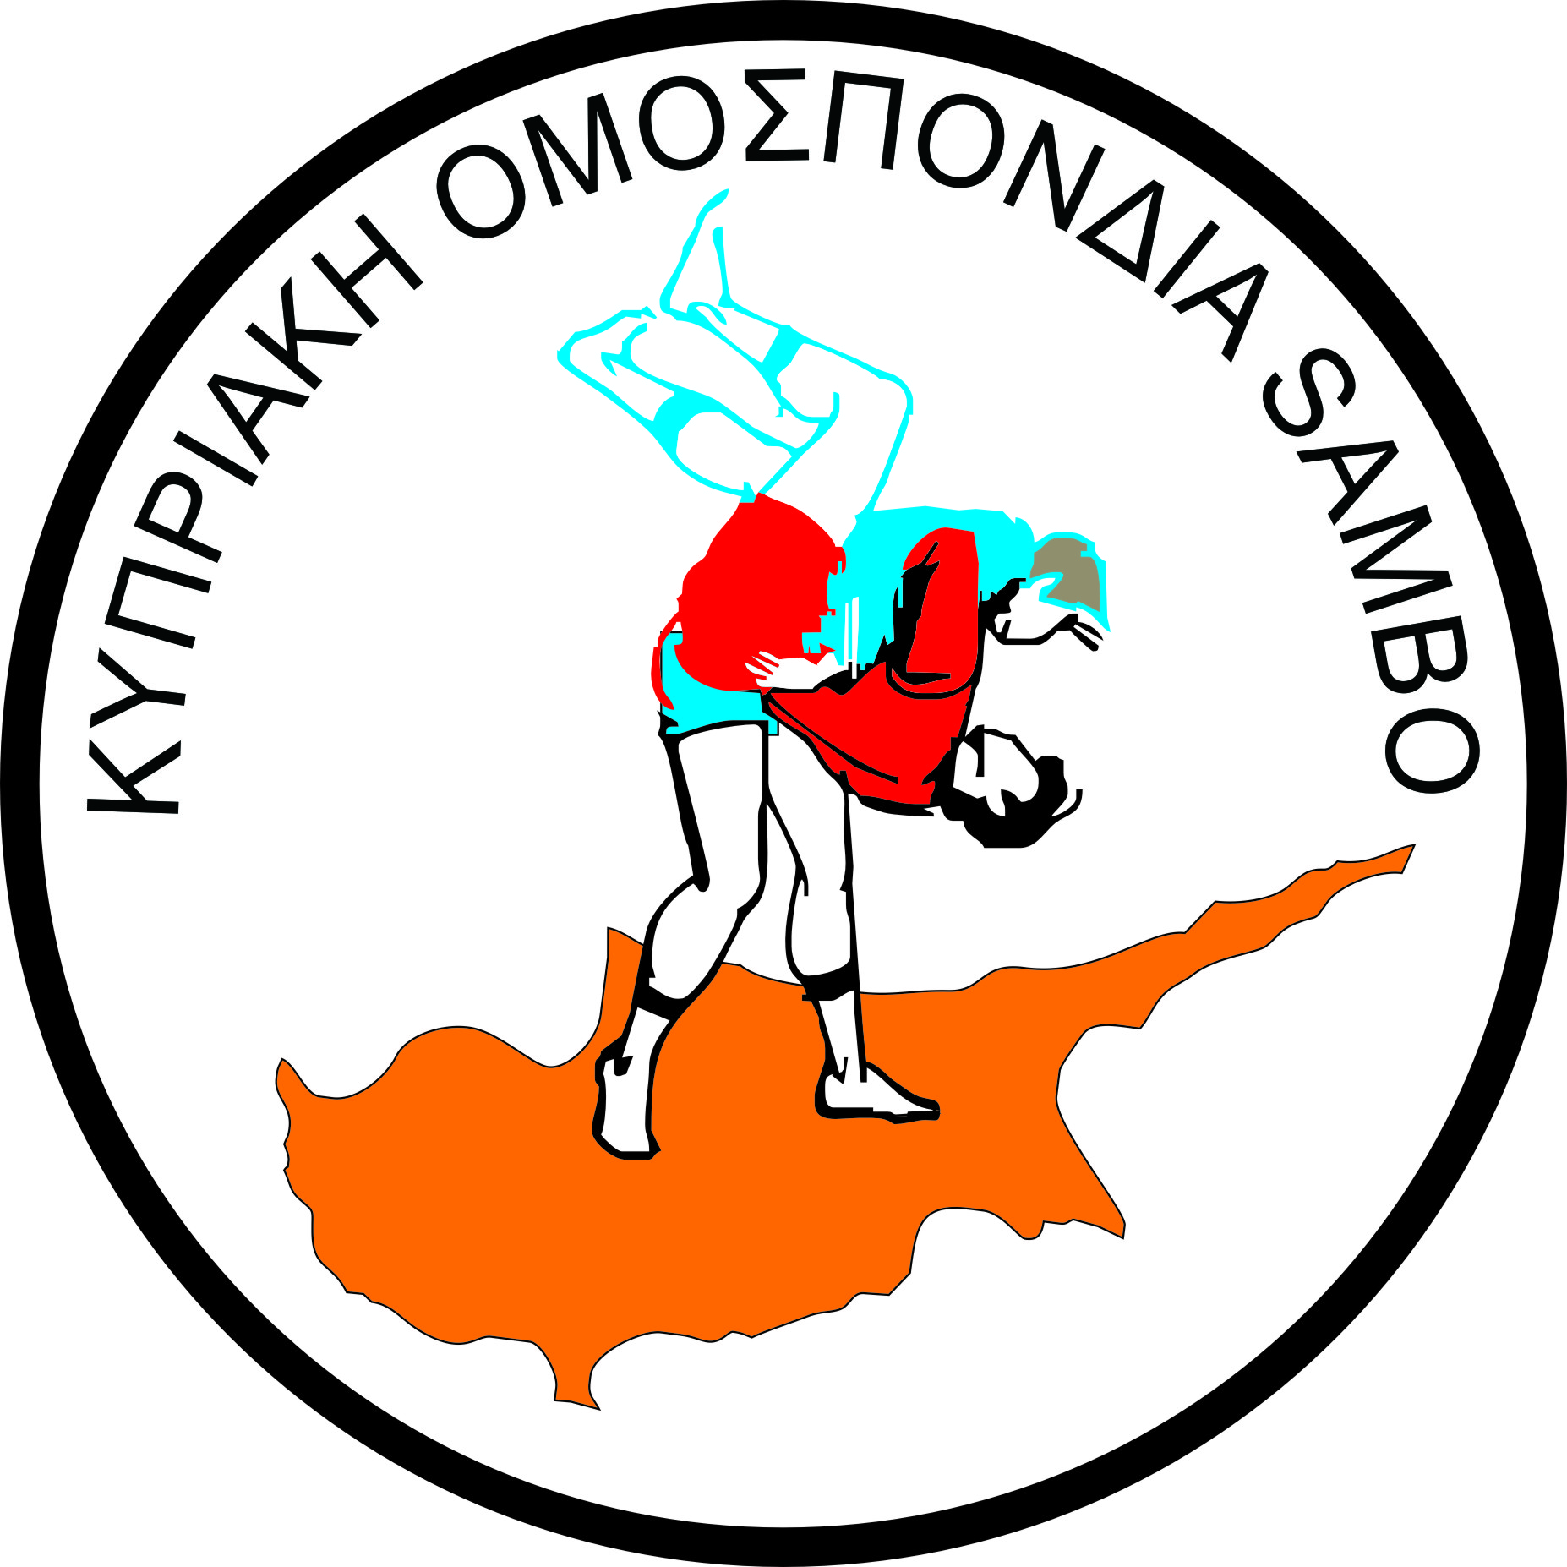

European Federation SAMBO Cyprus Sambo Federation
President, Sergey ELISEEV President, Marios Andreou

REGULATIONS
European SAMBO Championship among
Youth (M-F) and Juniors (M-F), Cyprus , Limassol
11-15 April 2013
1. General terms.
1.1 European Championship Sambo carried out in accordance with applicable Rules of Sambo
and Regulations of FIAS and EFS.
1.2 European Sambo Championship will be organized and conducted by the European
Sambo Federation (EFS) and the Cyprus Sambo Federation in cooperation with the Cypros Sport Organization (K.O.A).
1.3 European Sambo Championship held to popularize and develop sambo in Europe and
strengthen the sport of international relations.
2. Date and venue.
2.1 The competition will take place from 11 to 15 April 2013 in Limassol , Cyprus .
2.2 Place of competition and accreditation for team: Spyros Kyprianou Sports Center Limassol Polemidia http://www.cyprussports.org/sport-facilities/limassol/spyros-kyprianou-athletic-center.html
2.3 Place of residence: Park Beach Hotel http://www.parkbeach.cy.net/,
and Arsinoe Beach Hotel http://www.arsinoe-hotel.com/
2.4 Accreditation for the teams will be held in Arsinoe Beach Hotel
3. Conditions of participation.
3.1 National Sambo Federations affiliated to the European Federation SAMBO will take part in European Sambo Championship among Youth and Juniors.
3.2 Official allowed delegation staff:
Leader - 1
Youth (M) -10
Youth (F) -10
Juniors (M) -10
Juniors (F) -10
Coaches - 8
Medic - 2
Masseur - 1
Referees - 5
Reporter - 1
Translator - 1
Total: 59
A) The preliminary applications for the number of participation should be sent to the Championship Organizing Committee no later than 11 March 2013 in accordance with Annex № 1.
B) Cyprus Sambo Federation will provide visa support only those delegation, which will provide lists of participants in a timely manner in accordance with Annex № 2 no later than 11 March 2013.
C) Applications for booking accommodation and transfers shall be submitted to the Championship Organizing Committee no later than 11 March, 2013, in accordance with Annex № 3.
D) The final applications for the registration of athletes in weight category should be submitted to the Championship Organizing Committee no later than 11 March, 2013, in accordance with Annex №4.
4. Technicals specifications of the Championship:
Weight categories:
Juniors (M) born in 1994-1995 - 48,52,56,60,65,70,75,81,87, 87 kg
Juniors (F) born in 1994-1995 - 40,44,48,52,56,60,65,70,75, +75 kg
Youth (M) born in 1992-1993 - 48,52,57,62,68,74,82,90,100, 100 kg
Youth (F), born in 1992-1993 - 44,48,52,56,60,64,68,72,80, +80 kg
4.1 Competitions are conducted in accordance with the rules of FIAS.
4.2 Each athlete must be under a medical examination before leaving the country for the, the Championship, results of medical examinations should be marked in the SAMBO license.
4.3 All participants in sports delegations Organizing Committee guarantees provision first aid.
4.4 Team places are defined according to the points in the individual classification.
4.5 All participants, coaches, referees and representatives must have medical insurance.
The presence of insurance will be checked at weigh-in. Without health insurance athletes are not allowed to participate in the championship.
4.6 Only referees of the international category al the official FIAS invitation are allowed to referee. Referees’ work is paid by EFS.
4.7 All delegations must be in possession of an audio recording of the national anthem (SD), 2 National flag (1 X 2 meters).
5. Financial terms and rates
5.1 Each member of the official delegation is obliged to contribute 75 €/ day (2 meals, lodging).
5.2 Transfer to the airports Larnaca or Paphos-hotel-place of the competition and back, 20 € /person.
5.3 The heads of delegations to resolve all financial issues with the organizing committee the day
of arrival and fulfill all the requirements for accreditation.
5.4 Participants who arrive at the competition, but will not be included in the application 11 March, payment of 90 € / day.
5.5 The Organizing Committee provides food and lodging President EFS, Secretary General of EFS, the Chairman of referee committee, Chief referee, Chief Secretary and the 20 referees in accordance with the rules of EFS.
6. Awarding of winners
Sportsmen won prizes will be awarded with medals, diplomas and gifts.
7. Official ceremonies
7.1 Competitors participate in the official ceremonies of the European Championship in red jackets.
7.2 In honor of the winners will be performed the national anthem and raised the national flag.
7.3 Representatives of National Federations will be admitted to the VIP area just in the corresponding clothing in the sportswear admission will be limited.
8. Additional clause
8.0 The Cyprus airways( http ://cyprusair.com) is a General Sponsor of the European Sambo Championship 2013 Limassol Cyprus and they give 20% discount for all tickets with Cyprus Airways, for more information contact us and we give you code with 20% discount for air tickets Please read:
https://wl-prod.sabresonicweb.com/SSW2010/CYCY/webqtrip.html?execution=e1s1
In order to ensure the quality and organization of the tournament, as well as a necessary conditions for the participants, please send a request in a timely manner in accordance with the Annexes.
Cyprus Sambo Federation: Marios Andreou
FAX +357 22 730616
Telf +357 99 513619
mariossambo@mail.ru
Skype: mariossambo

