6-th INTERNATIONAL DR. PRANCIŠKUS EIGMINAS MEMORIAL SAMBO TOURNAMENT
VILNIUS 7-9 DECEMBER 2012
INVITATION 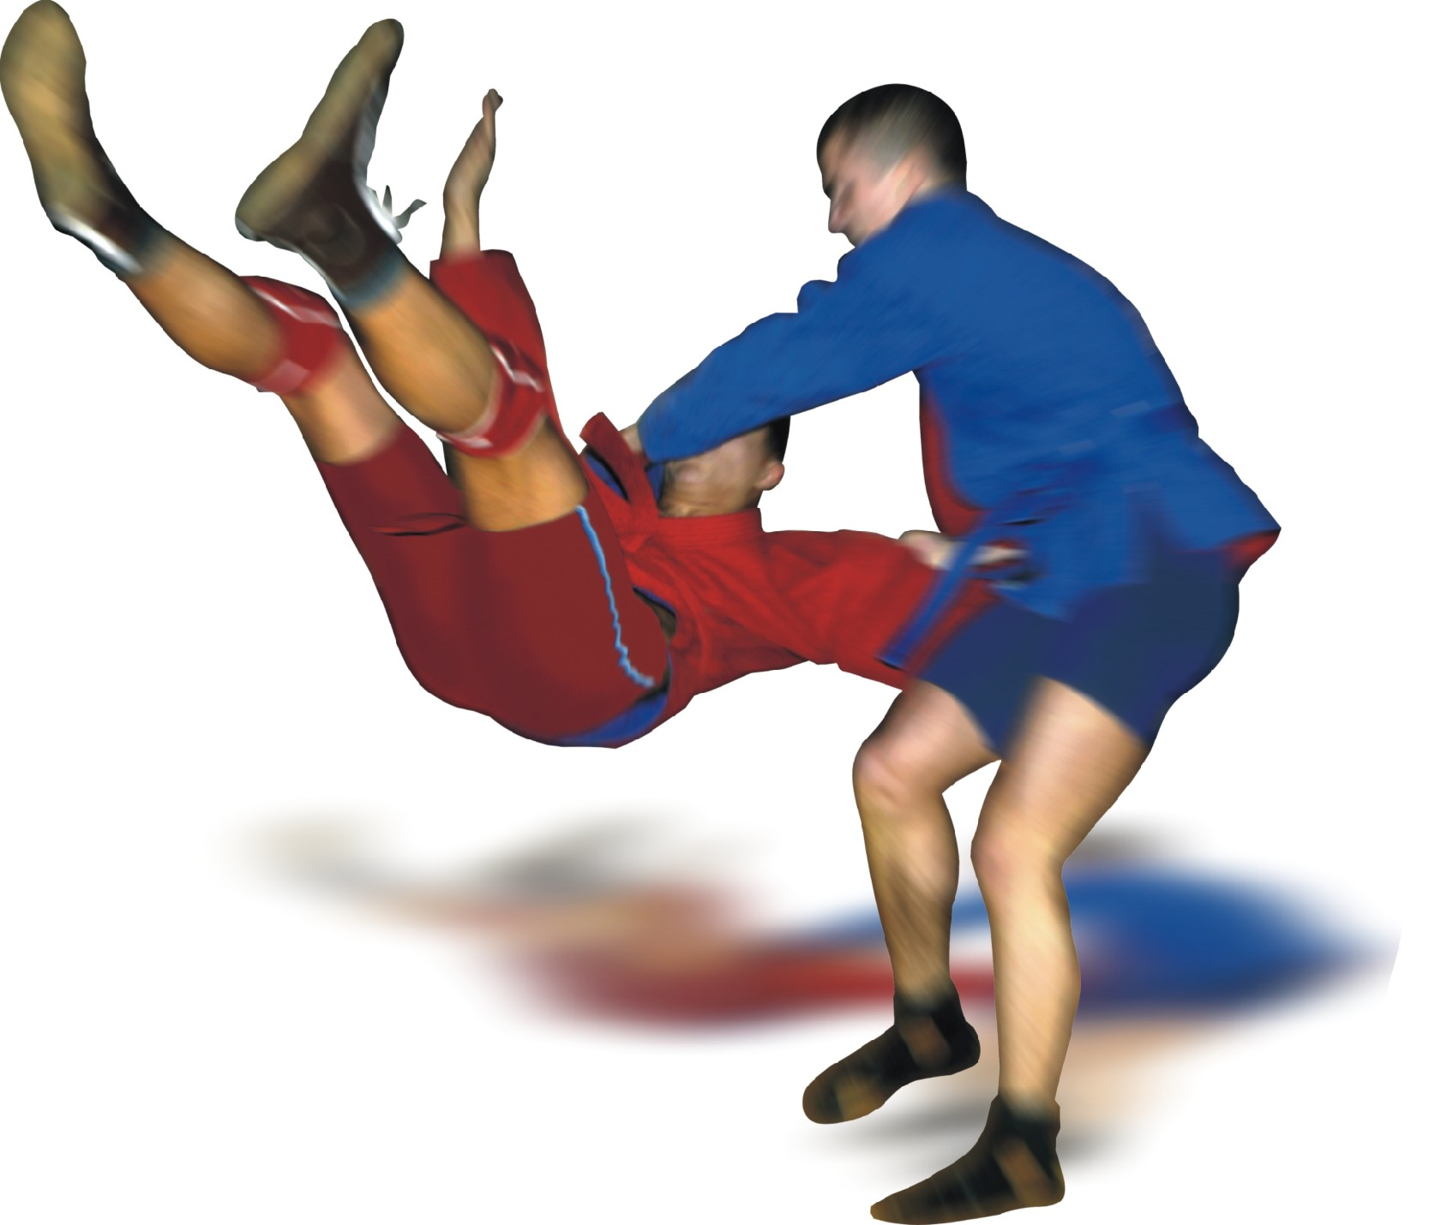

Dear President,

Lithuanian SAMBO Federation has the honour to invite You and delegation of your country to participate in international sambo tournament in memorial of Dr. Pranciskus Eigminas. Tournament will be held in Vilnius, Lithuania at 7-9 December 2012.
Age of competitors: YUOTH - dates of birth 1993-1996.
Competition address: Žirmunų 1E, Vilnius, Lithuania.

Program
7 December |  | Arrival
 | 12,00-16,00 | Mandate commision
 | 17,00-18,00 | Weigh-in : 56, 64, +64 kg (W)  48, 52, 57, 62, 68, 74, 82, +82 kg (M)
 | 18,00-19,00 | Technical meeting for referees coaches and team leaders
8 December | 11,00 | Opening ceremony
 | 11,30-14,00 | Competitions in weight categories: 56, 64, +64 kg (W)  48, 52, 57 kg (M)
 | 14,00-18,00 | Competitions in weight categories 62, 68,74, 82, +82 kg (M)
 | 18,00-19,00 | Awarding ceremony
9 December | 10,00-12,00 | Excursion to city
 | 12,00-24,00 | Departure of the delegations

Conditions

Organizing Committee invites Your team: 2 (two) sportsman, 2 (two) coach/official without entry and accommodation fee! Participation and accommodation fee for delegation members above mentioned limits is 50 EURO per day. National delegations please take State flag.

Please send your entries until 1 December 2012 to:
Lithuanian SAMBO federation
Žemaitės-6 Vilnius, Lithuania
Tel. + 370 5 2163926
Fax. + 370 5 262 49
Mob. tel. + 370 686 67323
E-mail info@sambo.lt; e.rudas@lkka.lt

WELCOME TO VILNIUS, LITHUANIA , THE INTERNATIONAL DR. P.EIGMINAS
SAMBO MEMORIAL 7-9 December 2012

President of Lithuanian SAMBO federation Eduardas Rudas

