World Masters Sambo Championships

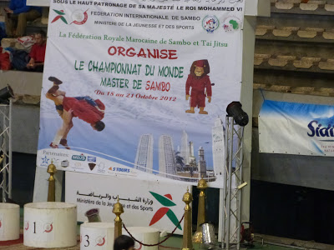

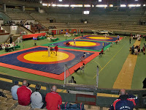
The venue for this event was the Mohammed V stadium Casablanca la very impressive place with 3 full size mats as per usual the FIAS accreditation was pandemonium but once the tournament started it ran like clockwork. I had a couple of complaints and they were that there was no where in the stadium to get a coffee or snack, there was no memorabilia for sale. Also I expect due to an admin error there was no Union Flag and no mention of the UK in the programme list of participating countries, maybe this was the reason UK and Swiss team did not get a participation gift. These were just annoying because the main reason we were here was to compete in the Worlds.
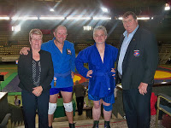
UK had small delegation BSF President Martin Clarke, Valerie Clarke BSF Ladies rep, Drew Cullen 50/54 years u90 k, Roland Newson 50/54 years u82 k.

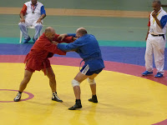Roland had a very experienced Russian fighter and done well only to lose on a 4 point hold down, sadly the competition system used at this event only allows those who lose to the finalist to come back in the repecharge. So Roland was out, I believe
F.I.A.S should adopt the system of the British Sombo Federation where you have a minimum of two matches. Roland is a very fit strong fighter so I am sure he will be in the medals next year.
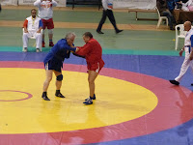Drew again had a hard fight fighting his first match with the eventual Russian Gold medalist, yet Drew has been training since he was 5 years old and did not give up. He fought in the u90k class to avoid having two players in the u82 k, Drew could not match the Russians strength but for man of his age he was very agile twisting out of throws but the outcome a loss on points was inevitable. His next fight was against a Ukrainian who arm locked him in the 3rd minute, so no medals for Team GB this time.
I always have admiration for men who put their reputation on the line, Swiss Sambo President Herve Gheldman was one of them who though unplaced had the courage to have a go.
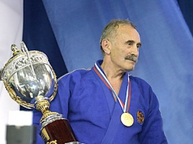Another was the famous Major General ASLAMBEK ASLAKHANOV a legend in Sambo and In the Eastern block. In 1967 he joined the police force and in 1988 played an instrumental role in saving hostages on board a plane in Mineralnye Vody, for which he was awarded the order of the red star. Author of Democracy Cannot Be Criminal, Mafia, the Fifth Power, and Mafia in Russia with No Sensation. Master of sports in Wrestling, Sambo, and Judo. Until 1987, was Vice President of Moscow Judo Federation, later was the President of the International Judo Federation uniting CIS countries' athletes. The 70 year old won both of his fights to take Gold but he could have easily have watched shaking people's hands, he won a lot of respect from a lot of people including mine, a man of courage.
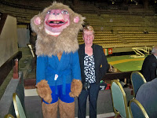Val with Mascot

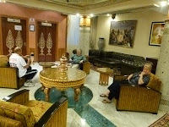
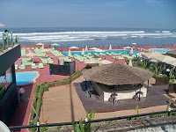This event was dominated by the Russians and Eastern block countries and it is a tough event and I hope I see more Western countries competing, yet Germany, France won medals and I was surprised to see how good the Moroccan team were.
As for Casablanca I found it a very safe and hospital place with reasonable priced restaurants, begging with deformed children and adults still gets to me though. Just a reminder that none of us were sponsored in any way, we all travelled at our own expense.

