Kurash Trials

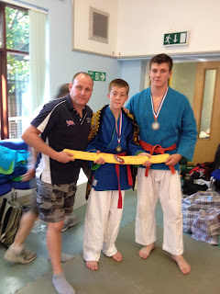

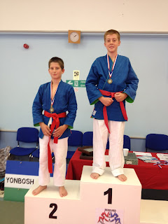

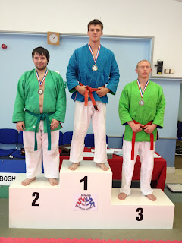

Jamie Marzetti and Lewis Clarke travelled to Bedford for the trials of the world youth and cadet kurash championships to be held in Bournemouth in october this year. Kurash is the national sport of Uzbekistan. It is another form of wrestling with no hold-downs or leg grabs. Lewis Clarke won all of his fights by total victory. He was also awarded fighter of the day and was given the traditional robe and belt of Uzbekistan. Jamie Marzetti also won all of his fights by total victory. Not only will Jamie be attending the Kurash Championships as part of the British team he will also be representing his country at the World Sombo Championships in Minsk two weeks later. Coach John Clarke who has also been British kurash champion twice, has said he is very proud of both competitors and it goes to show the high-calibre of fighter that is coming out of warriors grappling academy in Sittingbourne.

