British Sombo Trials

British Sombo Federation
British Sombo/Full Contact Sombo (Combat Sambo) Trials
Saturday July 28th 2012
The BSF organised this extremely successful event along side the Midland Open Sombo Championships. The event started with the trials first followed by the competition, as expected we did not get a large entry as it was players who wanted to participate in the Worlds who would only attend, what this did produce was the best Sombo Team GB has seen. A downside was that we had no women entries and this is something the BSF needs to correct for the future. The star of the day was 100k plus Matthew Clempner who is a No 1 Judo player; he is son of famous Olympian Matthew Senior. He coasted through the trials and it has been many years since the BSF can say they have a chance of a World Medal although all this years team have a chance of a medal if they get a good draw. The BSF decision to have a trial proved the right one.

World Championship GB Sombo Team
U57k Bradley Belsey England.
U62k Casey Belsey England
U68k Ashley Costa England
U74k Reece Armstrong Scotland
U82k Jamie Marzetti England
U90k Johannes Alder Scotland
U100k Barry Gibson England
O100k Matthew Clempner England

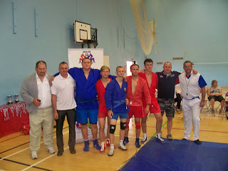

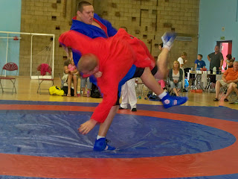

The Combat Sambo trials were controversial because the bleating of a couple of Coaches who wanted to use the British Open and Scottish SportCombatSombo Championships as the trials. This was a ridiculous idea as SportCombatSombo is a much watered down version of Combat Sambo and was devised by Martin Clarke to conform with Insurance requirement so Sombo Player could compete. CombatSombo is a registered Service Mark with Martin Clarke. Combat Sambo is a very hard aggressive competition form of Full Contact Punching, Kicking and Head Butting standing and on the ground including strikes to the groin none of these are allowed in SportCombatSombo. So it would have been irresponsible for the BSF to select on those grounds plus there would be a Health and Safety issue, as a governing body the BSF has a duty of care and a legal obligation to make sure competitors are fit, healthy and experienced in their sport. Obviously something these bleating coaches do not have for their competitors. The trials only attracted a few entries and the general feeling was that was good as it only attracted those who were confident and had been training in Combat Sambo in what was the First ever Combat Sambo event in GB
Combat Sambo UK Team
U82k Ryan Trebitcock
U100k Barry Gibson England
O100k Ben Whitehead England

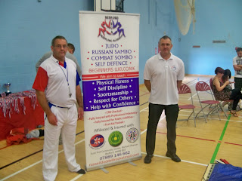

For the First time in BSF History the FIAS President Mr Shestakov has promised to pay for the British delegations accommodation Belarus. Yet the British Team will still need to pay for their own flight, visa and FIAS license. Since the start of the BSF in 1986 when it was started by Martin Clarke everyone has had to fund themselves and for Officials of the BSF they have had to finance all their travel throughout GB and the World. The very first event the BSF participated in was the World Championships in Pau France in 1986, this is where Martin Clarke purchased an old ambulance and drove the team. Yet as soon as some hear there is money being invested in a sport, they demand some and accuse others of having their own personal fund; yet the same people have never invested anything in the Sport
The future looks good for British Sombo; there is now easy access to equipment and several tournaments are planned a new selection is to be used all potential international competitors can gain points by attending a Division 1 tournament. There will be three Division 1 tournaments in March English Open Sittingbourne, May British Open Bedford, July Scottish Open Dumfries all these will have Sombo. At present the only Division 1 Combat Sambo event will be at the British Open, the British CombatSombo Association will run the only SportCombatSombo events.
Other events this year will be a Red Star event Scotland, Bedford Grappling Academy Event, Warriors Grappling Academy events Sittingbourne and BCSA British CombatSombo Jacket and Non Jacket Wrestling competition Sittingbourne

