European Sambo Championships

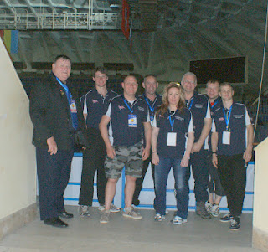

British Team

Members of the British Sombo Federation recently attended the European Sambo Championships in Moscow, for the first time the British Team were given free accommodation from the European Sambo Federation which was greatly appreciated but we still had the flight to pay for £220 and Visa £105 as the British Sombo Federation gets no funding. Members who attended were Martin Clarke British Sombo Federation President, Colin Carrott English Sombo Federation President, John Clarke BSF National Coach, Peter Wise BSF EC members, Dave Wellsman Spectator, Julie Halstead Competitor, Tom Richardson Competitor, Bradley Belsey Competitor. Brother Casey was also supposed to compete but had his visa refused because it was dirty, the Russian Visa Department are so disorganised that he never got his passport back till the Saturday we were in Russia. Interestingly enough him and his brother sent their visa application of together Bradley got his back 10 days before we were due to leave and on the same day Casey had a telephone call on the same day telling him that his visa had been rejected because of the passport, yet they refused to send his passport back in time so he could get a new one and they never refunded his visa money. Casey is 19 years old because of this he lost all his money and a chance to represent his country. He was not our only team member not to go because of Russian Visa Agencies inefficiency, Barry Gibson from the North East a potential Combat Sambo medal winner paid an extra £60 for express delivery i.e. a 1 day turn around which took two weeks and from Scotland BSF Chairman Robin Hyslop and BSF Treasurer John Sharpe had the same problem. I have sent a copy of this article to the Russian Embassy, Gordon Henderson MP, Dan Hannan MEP and the Foreign Secretary Haig MP and hopefully they will stick a banger up the company who organises the Visa. So our original team was 4 Sambo players and 3 Combat Sambo what with the visa problem and injuries we end up with just 3 players
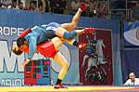

Now on to the important part it has been many years since a GB team has taken part in the European Championships purely because of finance, as I mentioned the BSF get no funding so everyone has to pay their own at a usual cost of a £1000 this is a lot of money, so we have restricted ourselves to the World Championships and the World Masters and in the latter we have been very successful with many of our members winning medals. The Worlds is a big difference as it is not always the best that go rather then those who can afford it, this is about to change in the future. The BSF have decided that from now on only those who will be allowed to enter will be those who are potential medal winner or those who will gain from the experience, other players will participate in lower level competitions. France, Germany, Italy and Holland offer good quality tournaments, which a BSF team can attend. Warriors President Martin Clarke has to travel sometimes several times a year to various parts of the World to attend competitions and meetings as President of the BSF he has done this since 1985 at his own expense.

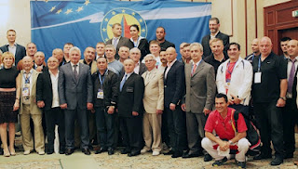

European Sombo Federation AGM

Before the competition there were many meetings which Martin had to attend and elections, it was pleasing to see that Mr. Sergey Eliseev, President of the All-Russian Sambo Federation, was elected President of the European Sambo Federation. He has always been very helpful to the British Sombo Federation and we will continue to support him. Many things were discussed at the meeting and as usual Martin had his say. The one thing to change was that affiliation payments, which have been made in US Dollars, have been changed to Euro’s. Martin questioned why change from a strong currency to one that will be extinct in a couple of years, knowing Martin’s opinion on the EU some members had a little laugh, he was the only one to oppose the motion. The issue of funding was another interesting debate with the ESF and FIAS boasting how they had given Jackets, boots, shorts, mats, canvases, and sent Coaches all over the world. Martin asked why since the formation of FIAS GB has been a member they have only received 10 junior kits? He personally has invested thousands of pounds in a having Sambo equipment made why were they left out? He suggested instead of paying Technical Advisors absorbent pay, they should support Team GB with financial aid in sending teams to the various competitions. He said he had told them that the BSF get no grant aid and is completely self funding and we are ever to get a quality team together we need to have help, at a meeting in March a proposed Commonwealth Sambo Association was put forward. At this meeting we were told there would be plenty of money to support it especially as we were to have Lord as President and Millionaire as vice president, where is it? The president of ESF Mr. Sergey Eliseev promised to look in to the matter and he is one of the few on FIAS who do what he promised

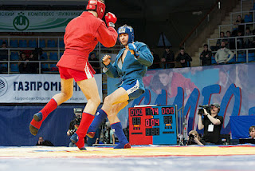

The European Sambo Federation organised a marvellous tournament one of the best we have seen, it had 33 countries entered when Martin Clarke and the BSF organised the European Championships in Herne Bay 1989 there was just 14 countries (that was before the break up of the USSR). The standard was unbelievable and with 3 mats on the go and a big TV screen you never missed a second, the International Federation (FIAS) has its own TV www.sambo.tv which if you have a computer you can watch at any time. This event was held over 3 days and on each mat was a different section Mat1 Men’s Sambo(in UK we have to call it Sombo) Mat2 Ladies Sambo Mat3 Combat Sambo. Sambo is the jacket wrestling style some used to compare it with Judo but with Judo changing their rules over recent years and eliminating a mass of techniques, Sambo has become the more spectacular. Combat Sambo is Jacket Wrestling which also allows striking, the scoring is very similar to Sambo but you can also knock a person out, some call it MMA with a Jacket, I think it is a lot more then that. When you see them coming in punches, kicks, knees and then you see a massive throw followed by an arm lock you have to hold your breath in awe. Of course they wear protective helmets, gloves, shin guards etc. but what I like most it is done on the mat not in a cage or ring, still hard but no one gets beaten silly because they are trapped. Yes you do see the odd knockout and a bit of blood but nobody gets seriously injured, this can still be a participation sport rather then just a spectators sport like Cage Fighting.

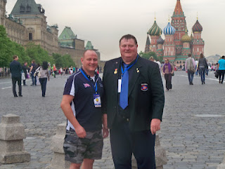

Father and Son at Red Square

The BSF first fighter was Bradley Belsey u62k. Bradley is quite a famous Judo Player locally him and his brother Casey have ben taught by their father Rob since a very early age in his early years Rob was a well-known competitor. Bradley is a Nationally ranked Judo player and is one of the fittest and most dedicated player we have seen in a long while. About 12 months ago both brothers wanted to try MMA and Sombo, the obvious place to go was Warriors Grappling Academy and be coached by National Sombo Coach John Clarke. Both lads were selected to represent GB in the Europeans I have explained what happened to Casey.
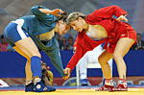

Bradley only had the one fight and that was against Octavian Taku Moldavia although he lost 12 pts to nil it did not really show the true depth of the match. Bradley gave a good account of himself but because he was used to the modern rules of Judo this hindered him. The first 6pts he lost was on leg grabs something allowed in Judo up to a few years ago he also got penalised for grabbing the hands. The Moldavian went on to lose to the Russian the eventual Gold medallist on a 1 pt. throw which put Casey out of the running for Bronze as the repercharge system only allows you to come back for Bronze if you lose to the Finalist. The Moldavian won Bronze if the system allowed a minimum of 2 fights I am sure Bradley would have given a good account of himself. Instead of being disheartened he has come back with a real bounce and has decided to move down to 57k watch this young man he is a medal winner.

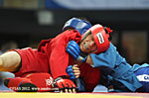

Next out was Julia Halstead u68k ladies, Julia a 2nd Dan Judo player was very nervous as were all the contestants, her one only fight was against a giant of a women from Ukraine who stood nearly 8 inches taller then Julia. She was caught on a foot throw for a total, I am sure if Julia had another match she would have improved. These Sambo women like the med will diet down, Julia who is good shape would have to drop one maybe two weights to stand a chance. She was the only women on the Team and she gave her best
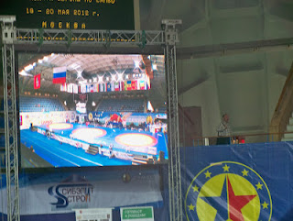

Tom Richardson was our Combat Sambo fighter at 20 years of age he was an unknown quantity was he any good or could he talk a good fight. Well pleasing he could fight as one of our team members said “he is not afraid of a row” He again only had one fight and managed to take several points of the eventual bronze medallist. He was most probably superior in striking but his weakness was his grappling he eventual lost on a arm lock but a potential future champion see the video and see what you think? They were very strict on equipment everything had to match colour wise Blue Helmet, Blue Gloves, Blue Jacket, Blue Shorts and blue pull on shin and instep and No velcro

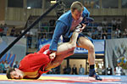

Martin Clarke as President of the BSF has put forward a slightly different elimination system so every fighter has a minimum of two fights, considering some travel thousands of miles and pay hundreds of pounds he believes this is a reasonable request

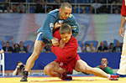

The European Championships was a great event and we all learnt a lot
Once again well done the European Sambo Federation you can get all the full results by going to http://www.sambo.com/results.html

The BSF continues to grow and we have many more members joined us if you want to have one of our Coaches visit you let us know, the BSF is offering courses in Full Contact Sombo, Sombo plus Sombo Grading’s. In July we have two tournaments one in Scotland and one in Bedford if you want to be considered for the Worlds you must turn up at Bedford also we have the first ever Commonwealth Sombo Championships in Dumfries Scotland in September.
John Clarke BSF National Coach will be Coaching and Lecturing at the first MMA Instructors Course organised by the British CombatSombo Association at the Swale Martial Arts Club contact John 07825224940

