Photo Guidelines
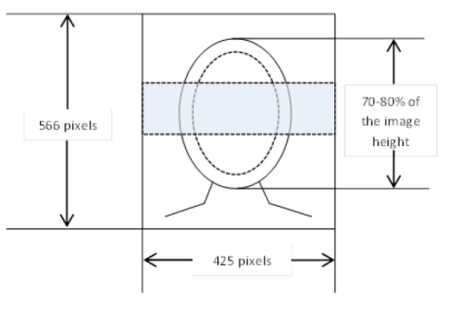
Size and Format:
- In colour (not black and white)
- Minimum 425x566 pixels (WxH)
- Format: *jpeg (*.jpg)

The photographs must be:
- taken against a plain white, light grey or light cream background free from shadows;
- taken in full-face view directly facing the camera, chin and shoulders must be visible with a neutral expression with the mouth closed (no grinning, frowning or raised eyebrows);
- taken with the eyes open looking straight at the camera and clearly visible (with no sunglasses or tinted spectacles, and no hair across the eyes);
- in sharp focus and clear;
- free from reflection or glare on spectacles, the frames of which must not cover any part of the eyes;
- taken of the full head, without any covering unless worn for religious reasons (provided that a person is photographed likewise in the passport);
- of each person on their own (no objects, chair backs or other people visible);
- free from any editing to improve or alter the appearance in any way;
- taken no earlier than 6 months before the documents are submitted;
- originals only (copied or scanned photographs are NOT acceptable).

