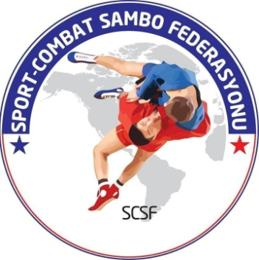 | PROGRAMME OF THE  EUROPEAN CHAMPIONSHIP AMONG CADETS  04-07 december 2015, istanbul, turkey
Turkish Sport-Combat Sambo Federation www.turkiyesambo.org

December 04 |  | Day of arrival
 | 11:00-17:00 | admission commission, accreditation
 | 18:00-19:00 | Weigh-in : Boys – 42,50,60,72,84 kg  Girls – 38,44,52,60,70 kg  in “Siyavuspasa Sport Complex”
 | 19:00-21:30 | Dinner in” Seminal Hotel”
 | 19:00-20:00 | Referees and Team Representatives Meeting
December 05
 | 07:30-09:00 | Breakfast in ” Seminal Hotel”
 | 10:00-16:00 | Competitions in the following weight categories:  Boys – 42,50,60,72,84 kg  Girls – 38,44,52,60,70 kg
 | 15:00-16:00 | Weigh-in in “Siyavuspasa Sport Complex” :  Boys: 46,55,66,78,+84 kg ; Girls:41,48,56,65,+70 kg
 | 16.30:17.00 | Opening Ceremony
 | 17:00-19:00 | Finals, awarding ceremony
 | 19:00-21:30 | Dinner ” Seminal Hotel”
December 06
 | 07:30-09:00 | Breakfast in ” Seminal Hotel”
 | 10:00-16:00 | Competitions in the following weight categories:  Boys:46,55,66,78,+84 kg ; Girls:41,48,56,65,+70 kg  in “Siyavuspasa Sport Complex”
 | 17:00-19:00 | Finals  Awarding ceremony
 | 19:00-21:30 | Dinner ” Seminal Hotel”
December 07 |  | Departure of delegations

